Moers Festival 2023

The Moers festival was an enriching experience, especially in human terms. It was an opportunity to meet new people and exchange ideas with them about their culture, traditions and ideas. We were nine volunteers, all of different nationalities. As most of us were in our twenties, we were keen to open up to new horizons outside our studies, as well as helping the locals.
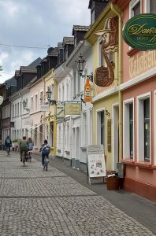Most of our missions took place during the three days of the festival. The rest of the time, we stayed together in a school lent by SCI. I particularly enjoyed the team spirit: preparing meals, getting together over a board game or a cup of tea, going for bike rides and so on.
What a show!
During the festival, we were organized in groups of three, and were just as much responsible for welcoming the artists and supplying the backstage area as for providing security with the other members gathered around the three concert stages. We worked eight hours a day, which turned out to be relatively short, as it was possible to attend the festivities, or meet up with other volunteers keen to chat. The atmosphere was truly exceptional, combining “hippie nostalgia”, with people dancing by the river, and “German-style relaxation”, as others laid on the grass, enjoying the smell of local market grilled meats and experimental music in the background.
The SCI team and the festival managers were really great. In addition to always listening and ensuring exemplary organization, they allowed us a certain flexibility, enabling the creation of a real community among our group of international volunteers.
I’ll be delighted to repeat the experience!
also readable at https://sci.ngo/vov/what-a-show-moers-festival/

